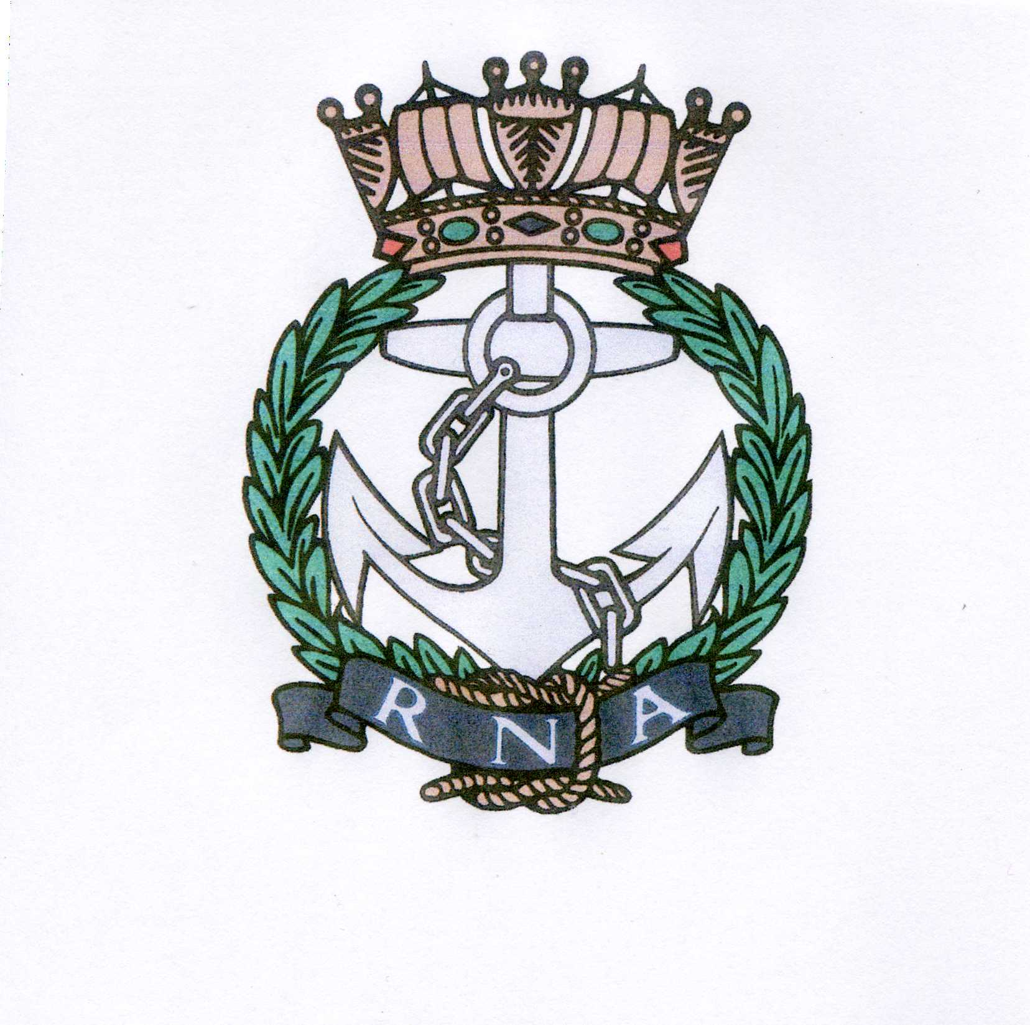
AQUITAINE BRANCH– ROYAL NAVAL ASSOCIATION
Chairman: Shipmate Ken Napier MBE
Chazarem, 47290 Beaugas
Email napier.chazarem@wanadoo.fr www.rna-aquitaine.com Tel 05 53 01 72 80

MINUTES OF ANNUAL GENERAL MEETING HELD AT THE RESTAURANT l’ÉTOILE, ST NEXANS ON WEDNESDAY 14TH MARCH 2018

- MEMBERS PRESENT: Ken Ayling, Chris Barnacle, Mike Brookes, Val Clarke, Albert Dijkstra, Don Goddard, John Hudson, Jeannette Kastelein, Mike Minter, Gareth Mulloy, Ken Napier, Sue Napier, Don Pike, Dave Rolfe, Liz Rolfe, Anne Scanlan.

- APOLOGIES: Richard Amott, Joan Amott, Andy Edouard, Robin Faulkner-Smith, Peter Glass, Davina Glass, John Larmuth, Angela Larmuth, Dave Pegg, Ray Pemble, Di Pemble, John Roberts, David Rollston-Smith, Neil Wilde, Julie Wilde.

- APPROVAL OF MINUTES FROM LAST AGM: The minutes from the AGM 2017 were read and accepted. Proposed Ken Ayling, seconded Liz Rolfe.

- ELECTION OF COMMITTEE: The existing committee were all willing to stand again and were re-elected ‘en masse’. Proposed Gareth Mulloy, seconded Val Clarke.

- CHAIRMAN’S REPORT: On 31st December we had a total of 72 members, 40 full members and 32 associate members. 4 members crossed the bar in 2017. We try to maintain the ratio of 4 full members to 3 associate members but with deaths and people returning to UK this is not always possible. We had 12 monthly lunches averaging 26 people at each lunch, at an average price of 21.50€. Most popular lunches were Trafalgar and Christmas, closely followed by the lunch hosted by Liz and Dave Rolfe. The Chairman thanked those who had organised lunches in the past year. The standard was paraded at Bergerac by Standard Bearer Neil Wilde on 8th May and 11th November. Ken paraded it at Blanquefort in December for the Cockleshell Heroes Commemoration. A Poppy Wreath was laid at Bergerac on the 11th November. The Chairman thanked Ken Ayling for his support and Rum Bosun activities, Dave Pegg as Treasurer, Ray Pemble for standing in when Dave was unavailable, Brian Johnson for his excellent menus and very well kept website, Liz Rolfe for her welfare role, sending out cards and Sue for her support and raffle organisation. A drop in membership numbers resulted in less income from subs and raffle ticket sales. The raffle ticket revenue is used for cards and champagne or flowers for members celebrating events, as well as for charitable donations. Our affiliated ship is RFA WAVE RULER, which has been in refit in Birkenhead in recent months. We have one officially affiliated serving man, Cdr Darren Houston, who is Executive Officer of HMS QUEEN ELIZABETH. Ken Ayling’s RNA stamps remain popular and can be used for 2nd class French mail. The RNA’s monthly newsletter is available on the internet under the heading Semaphore Circular. The Chairman gave special thanks to Brian Johnson for his maintenance of our excellent website, which receives worldwide ‘hits’. The monthly newsletter is to be found on this site. He thanked everyone for coming along and supporting the AGM.

- TREASURER’S REPORT: As the Treasurer was unavoidably detained Don Pike, who was one of the auditors, gave the report. The current bank balance had reduced by 467€, and the deposit account had increased by 41€ leaving an overall reduction of 426€, this is simply a reflection of our reduced membership and therefore raffle ticket sales. The amount of ‘emergency money’ held in our deposit account remains at 2000€. Main expenditures were subs to HQ and charitable donations of 1800€. Total expenditure for 2017 was 3333€. The Treasurer feels that subs can be held at the present level for next year.

Accounts were accepted, proposed Ken Ayling, seconded Val Clarke
Auditors for 2018 – Don Pike and Dave Rolfe. The Chairman thanked this years auditors , Don Pike and Albert Dijkstra for their work.
Albert Dijkstra commended Dave Pegg on his the excellent bookkeeping..

- ALLOCATION OF FUNDS: There is a total of 1700€ to be given to charity. It was decided to give to the usual 4 charities – RNBT, WRNSBT, ARNO and SSAFA in the following amounts:
RNBT - 450€
WRNSBT – 450€
ARNO - 450€
SSAFA - 300€
A total of 1650€, the remaining 50€ to be held over.
Proposed Mike Minter, seconded Chris Barnacle

- SOCIAL PROGRAMME: The date for the Trafalgar lunch was discussed. The nearest date is Wednesday 17th October. However the Chairman is charged to contact the Naval Attaché and invite him to join us, and to be our speaker, and to offer him the 10th, 17th or 24th of October in the hope that he will be available on one of those days. It was agreed that the Ancienne Gare at Issigeac is a central venue with good quality food.
Liz and Dave Rolfe offered to host the June lunch again, it will be a curry lunch but a non-curry option will be available.

- LIBRARY: There were no volunteers to take on the library so it was decided to disband it. Members present were invited to help themselves to any books they wanted and to make a small donation to the RNA. These books will be removed from the master list on the website and the remaining books can be offered to other members of the branch wishing to have one for the same small donation.

- ANY OTHER BUSINESS: RNA Stamps – Ken Ayling was asked to order more RNA stamps. They cost slightly more but are good publicity and are used mostly by Liz Rolfe when sending out cards and Ken when sending out the few monthly letters and other official mail.

Ken Ayling proposed a vote of thanks to Ken and Sue Napier for their work over the past 12 months.

The meeting closed at 11.55.

.

